Visual Design Plan
Table of Contents
Visual Design Plan 1
Design Overview 1
Website Pages Overview 1
Colour Scheme 5
Typography 5

Design Overview
My website has a simple design with a tabbed interface and a uniform layout. The goal is to make a website that is easy to use and can be adapted to easily add more content later.

Website Pages Overview
Navigation buttons are arranged like tabs in a web browser. When a tab is selected it appears darker to show this. The main content is placed in a box underneath the tabs to prevent it from being squashed against the edges of the browser.
The home page contains a link that brings you back to the main page of my course work: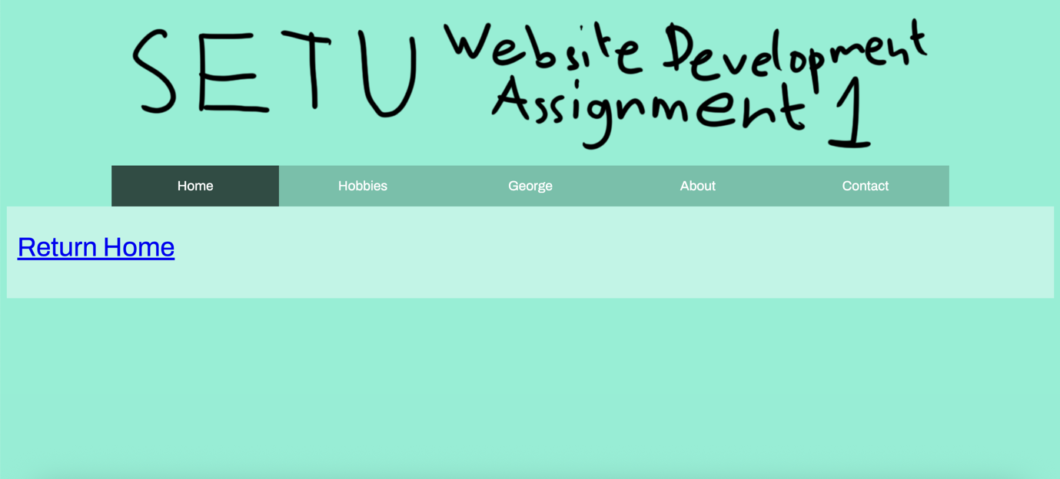

The “Hobbies” page contains information about some of my hobbies: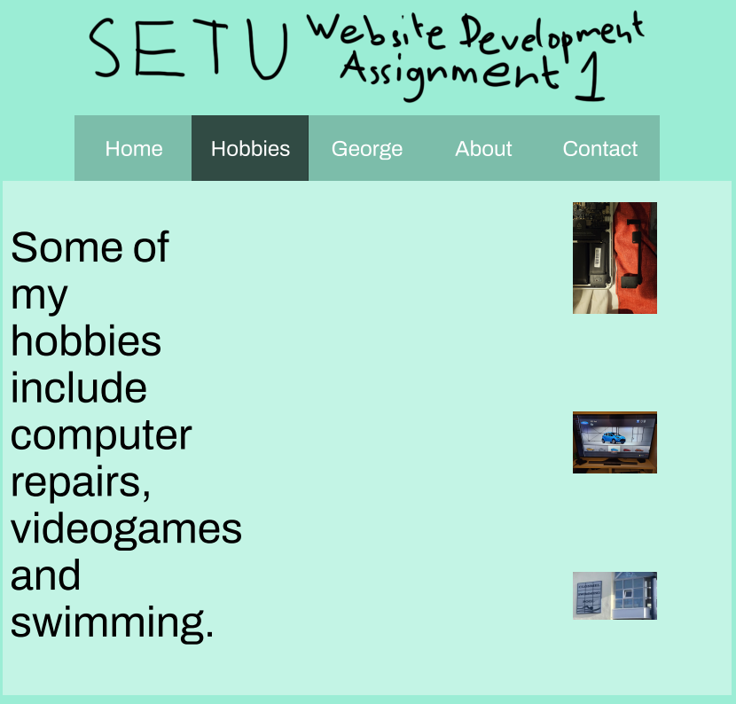

The “George” page contains information about my cat George: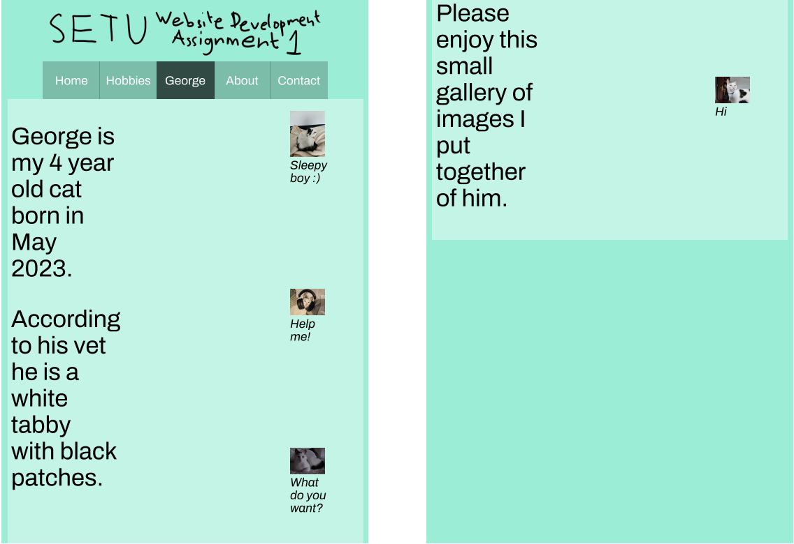

The “About” page contains information about me and this project: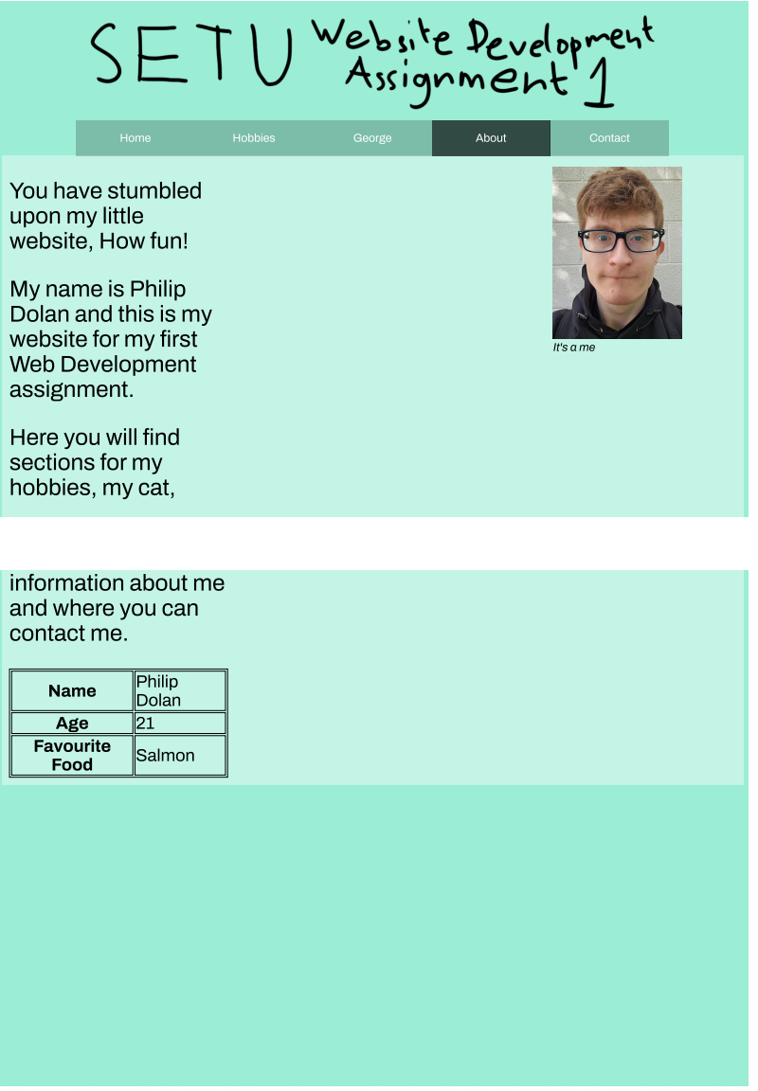

The “Contact” page contains information about how you can contact me: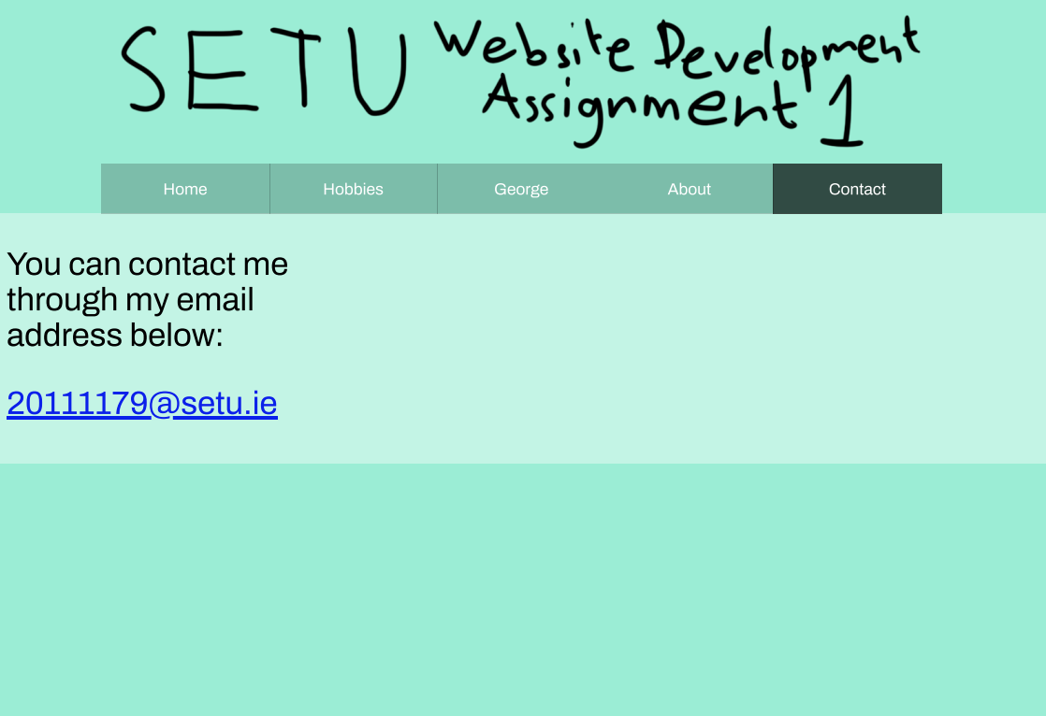

Colour Scheme
I chose a light green (#98EDD5) as it is a neutral calm colour, the text and navigation colours were chosen as analogous colours.

Typography
I chose “Archivo” as my font by looking through Google fonts and picking one that stood out to me.

